Google Cloud Essential Skills: Challenge Lab

## Your challenge

Your challenge is to deploy the site in the public cloud by completing the tasks below. You will use a simple Apache web server as a placeholder for the new site in this exercise. Good luck!

### Running a Basic Apache Web Server

A virtual machine instance on Compute Engine can be controlled like any standard Linux server. Deploy a simple Apache web server (a placeholder for the new product site) to learn the basics of running a server on a virtual machine instance.

#### Create a Linux VM Instance

Create a Linux virtual machine, name it "Apache" and specify the zone as "us-central1-a".

#### Enable Public Access to VM Instance

While creating the Linux instance, make sure to apply the appropriate firewall rules so that potential customers can find your new product.

Click **Check my progress** to verify the objective.

Create a Compute Engine instance, add necessary firewall rules.

Check my progress

#### Running a Basic Apache Web Server

A virtual machine instance on Compute Engine can be controlled like any standard Linux server. Deploy a simple Apache web server (a placeholder for the new product site) to learn the basics of running a server on a virtual machine instance.

Click **Check my progress** to verify the objective.

Add Apache2 HTTP Server to your instance

Check my progress

#### Test Your Server

Test that your instance is serving traffic on its external IP. You should see the "Hello World!" page (a placeholder for the new product site).

Click **Check my progress** to verify the objective.

Test your server

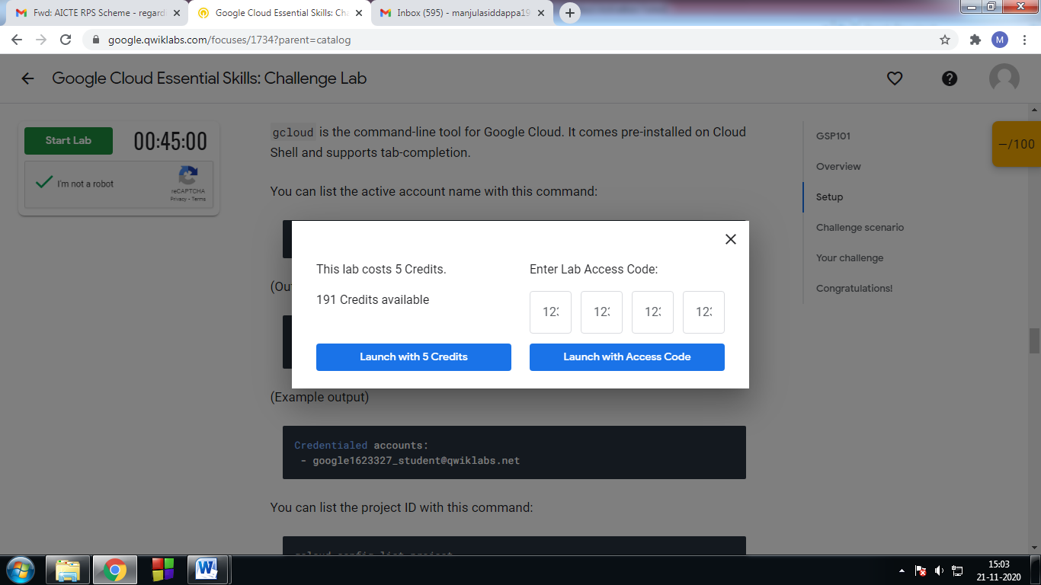

1. Click the **Start Lab** button. If you need to pay for the lab, a pop-up opens for you to select your payment method. On the left is a panel populated with the temporary credentials that you must use for this lab.

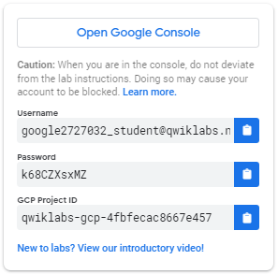

1. Copy the username, and then click **Open Google Console**. The lab spins up resources, and then opens another tab that shows the **Sign in** page.



**Tip:** Open the tabs in separate windows, side-by-side.If you see the **Choose an account** page, click **Use Another Account**

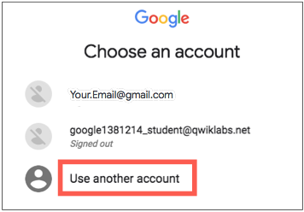

1. In the **Sign in** page, paste the username that you copied from the Connection Details panel. Then copy and paste the password.

**Important:** You must use the credentials from the Connection Details panel. Do not use your Qwiklabs credentials. If you have your own Google Cloud account, do not use it for this lab (avoids incurring charges).

1. Click through the subsequent pages:
   * Accept the terms and conditions.
   * Do not add recovery options or two-factor authentication (because this is a temporary account).
   * Do not sign up for free trials.

After a few moments, the Cloud Console opens in this tab.

**Note:** You can view the menu with a list of Google Cloud Products and Services by clicking the **Navigation menu** at the top-left. 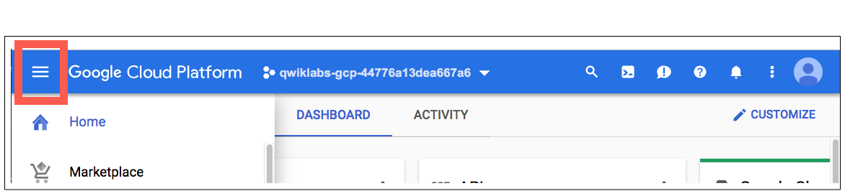

### Activate Cloud Shell

Cloud Shell is a virtual machine that is loaded with development tools. It offers a persistent 5GB home directory and runs on the Google Cloud. Cloud Shell provides command-line access to your Google Cloud resources.

In the Cloud Console, in the top right toolbar, click the **Activate Cloud Shell** button.

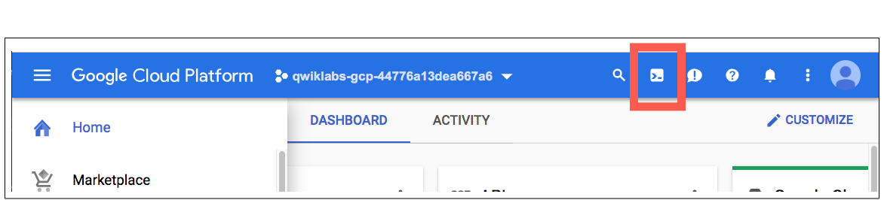

Click **Continue**.

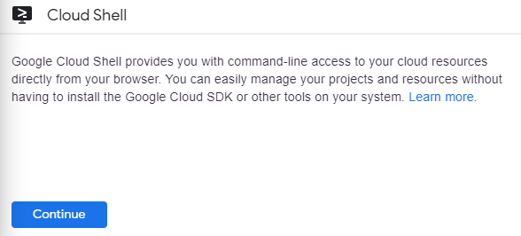

It takes a few moments to provision and connect to the environment. When you are connected, you are already authenticated, and the project is set to your PROJECT_ID. For example:

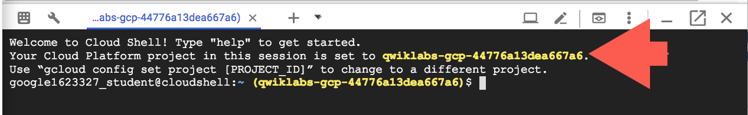

gcloud is the command-line tool for Google Cloud. It comes pre-installed on Cloud Shell and supports tab-completion.

You can list the active account name with this command:

gcloud auth list

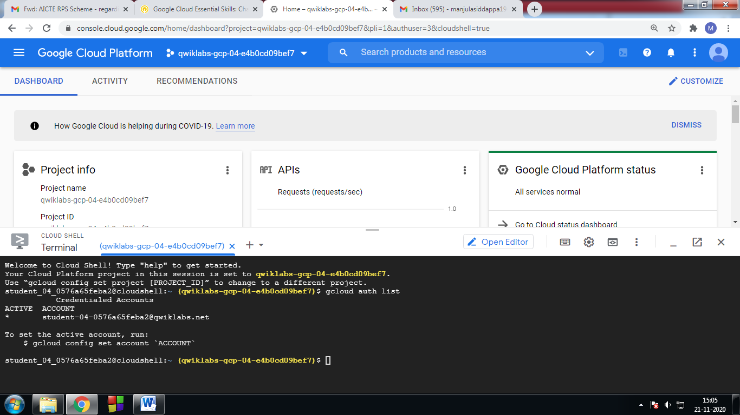

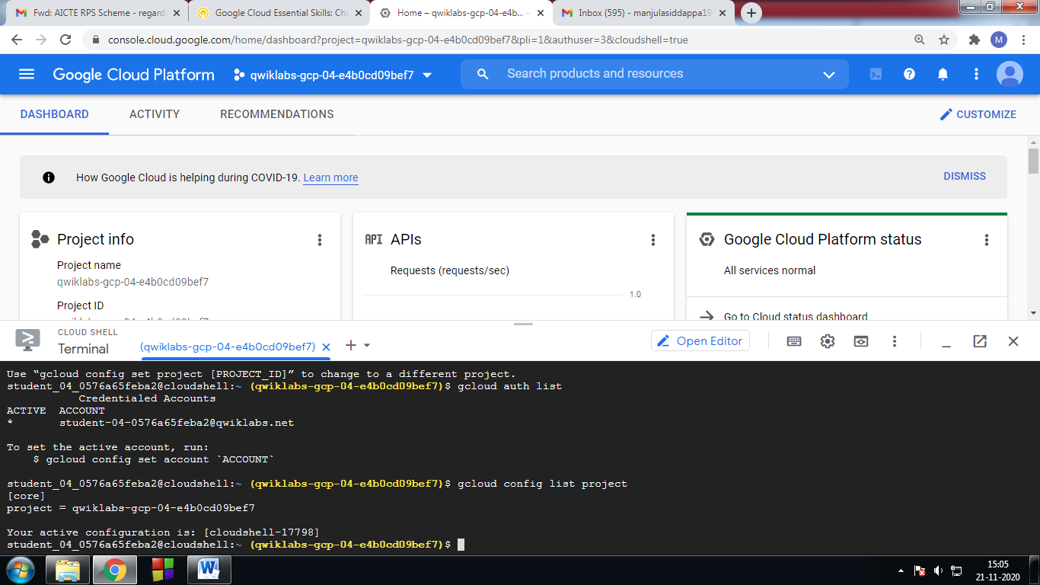

#### Create a Linux VM Instance

Go to **Compute Engine** > **VM Instance**

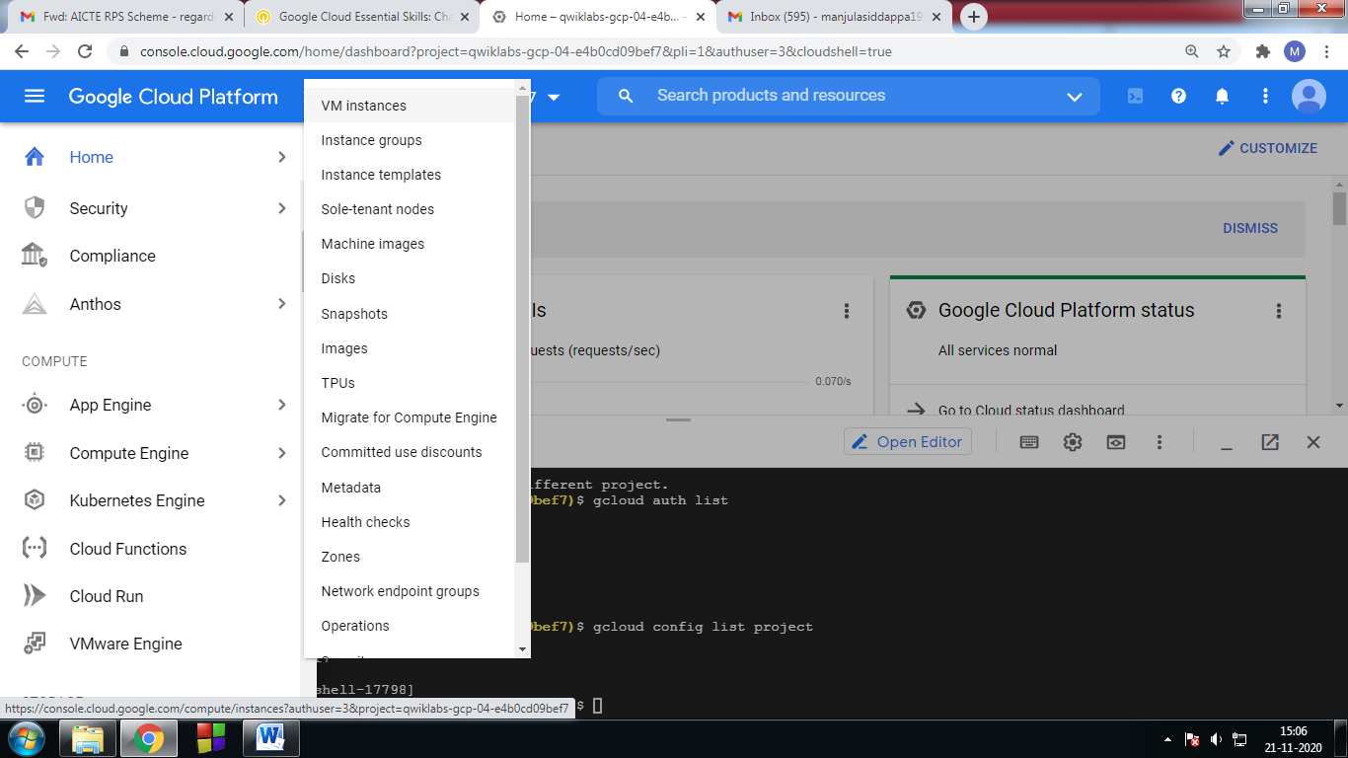

2. Click on VM instance -> Click on **Open link in new tab**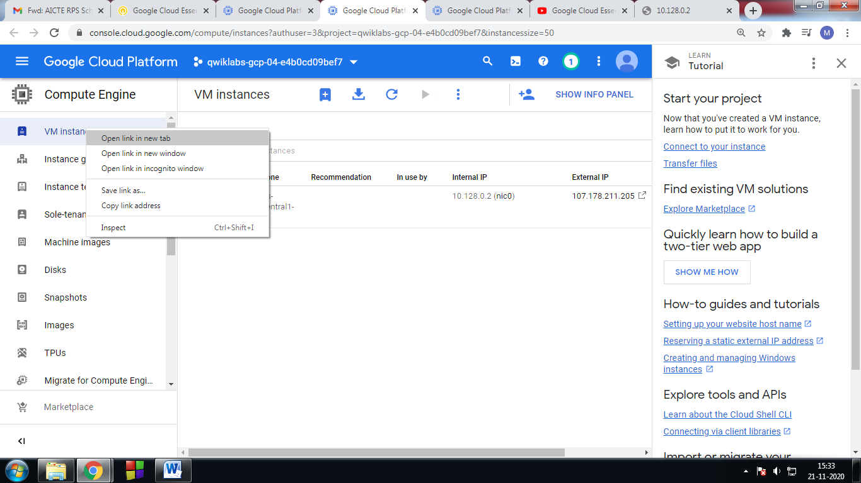

3. Create New VM instace

Name = apache, series = N1

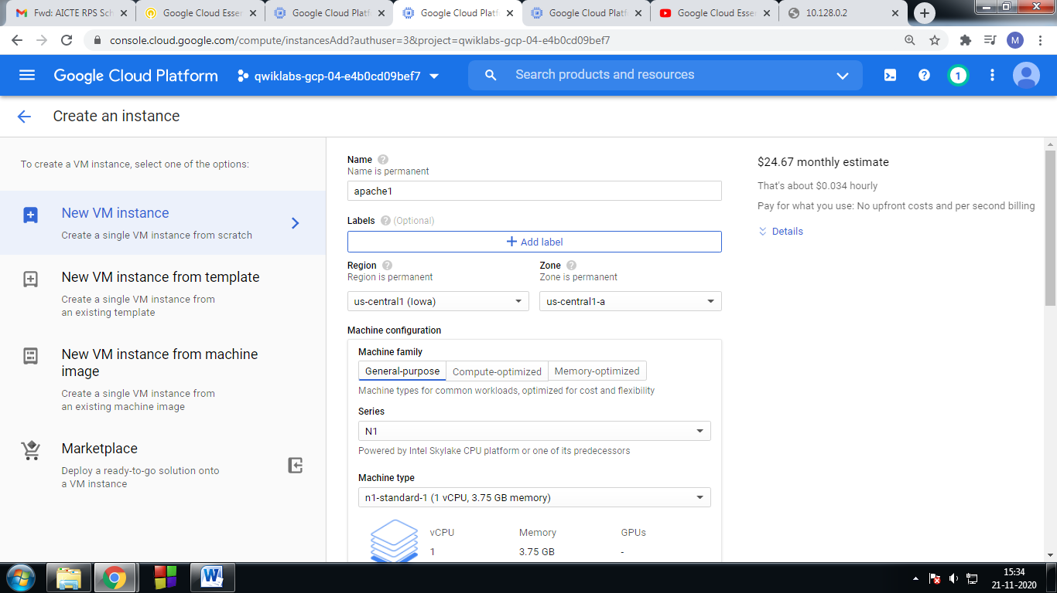

1. Then click on  CPU platform and GPU
2. 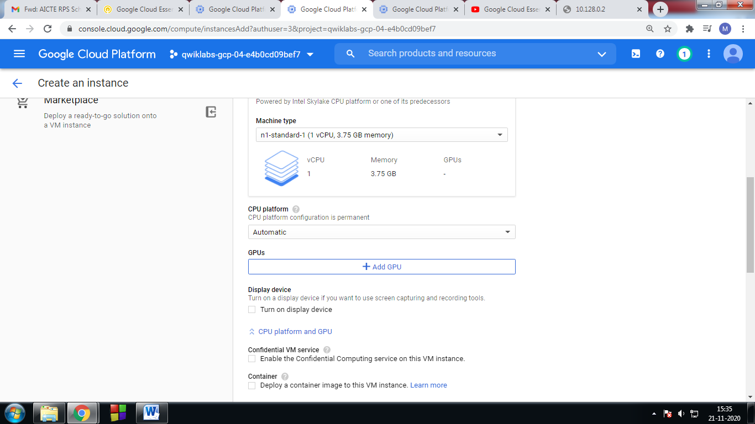

5. **In Boot disk** click on -> **change** 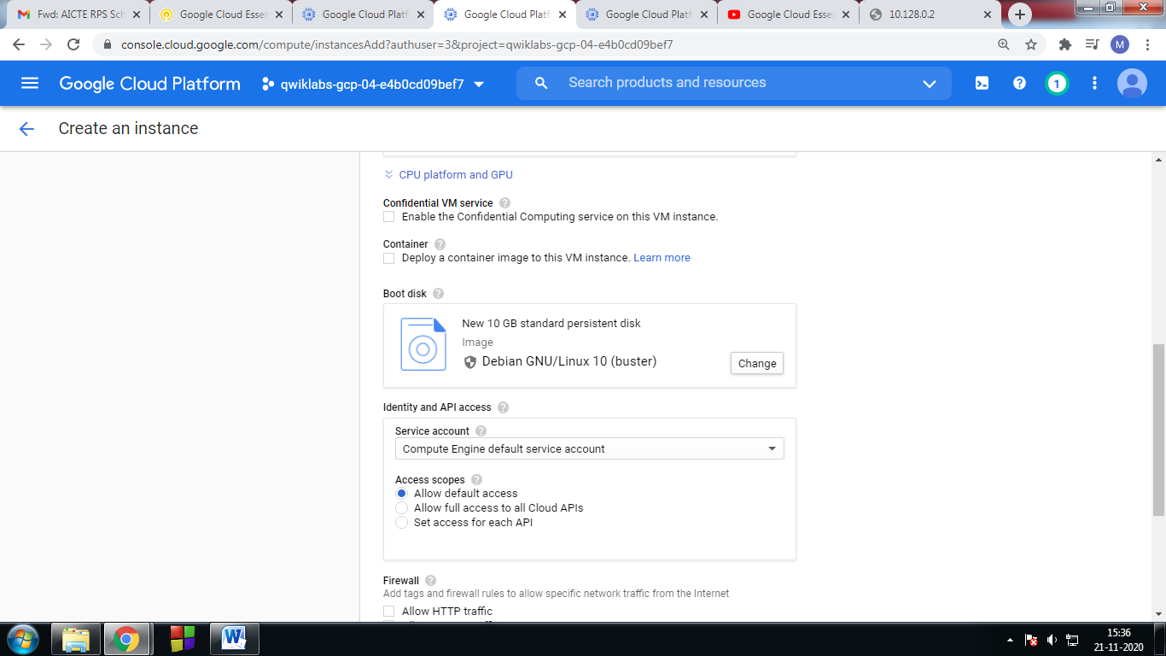

6. Change the version ->Debian GNU/Linux 9(Stretch) 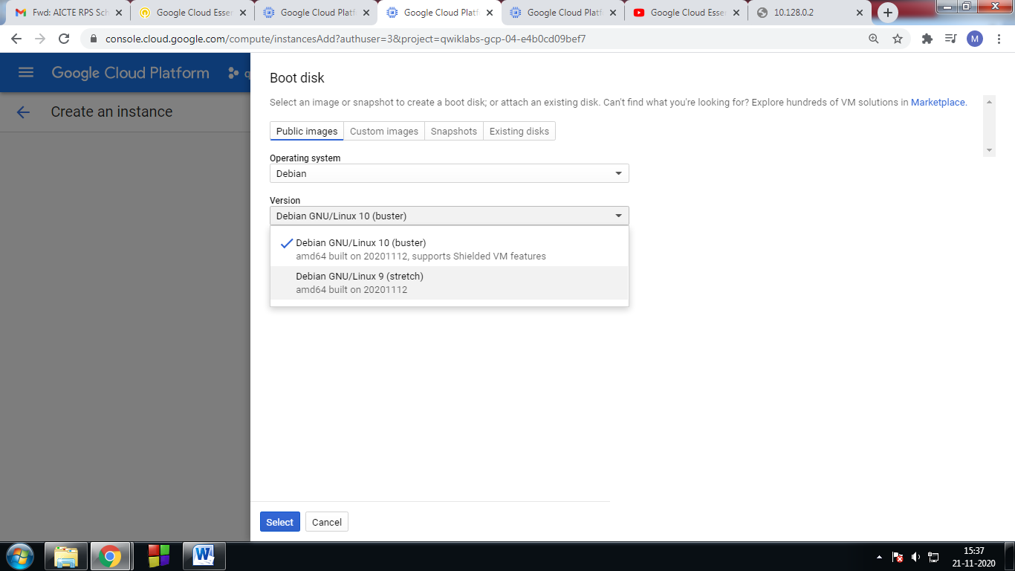

7. then click on select(bottom )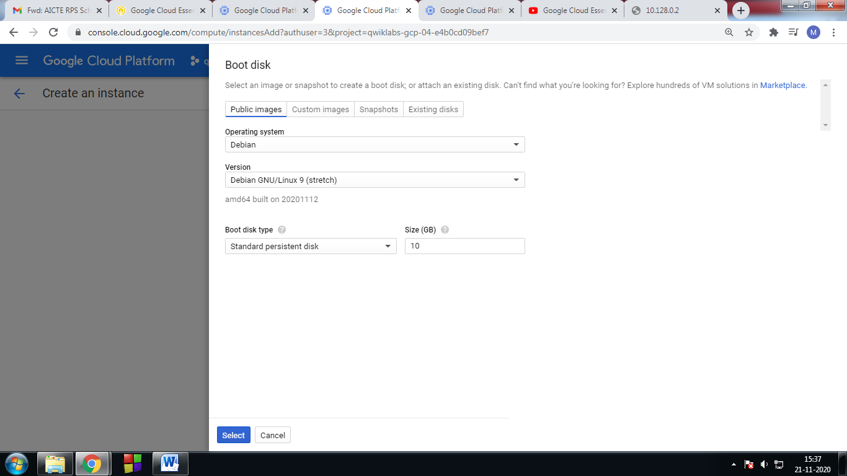

8. In Firewall select both check boxes than click on create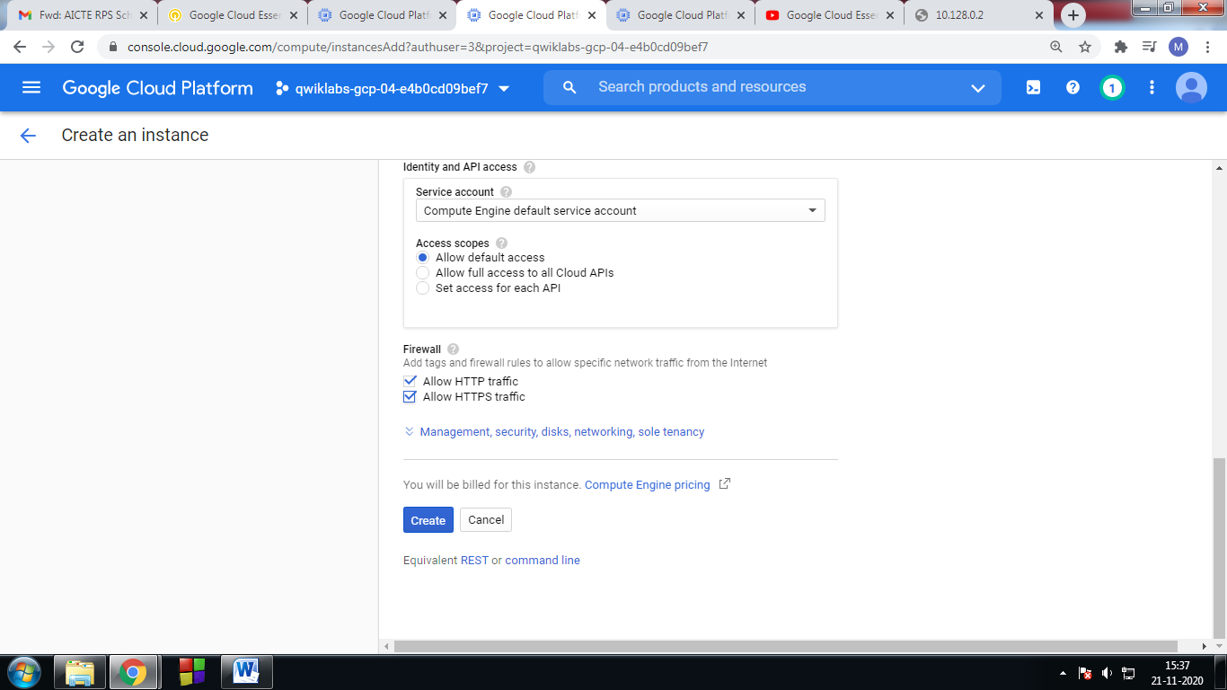

9. Compute Engine instance with necessary firewall rules 🡪 created

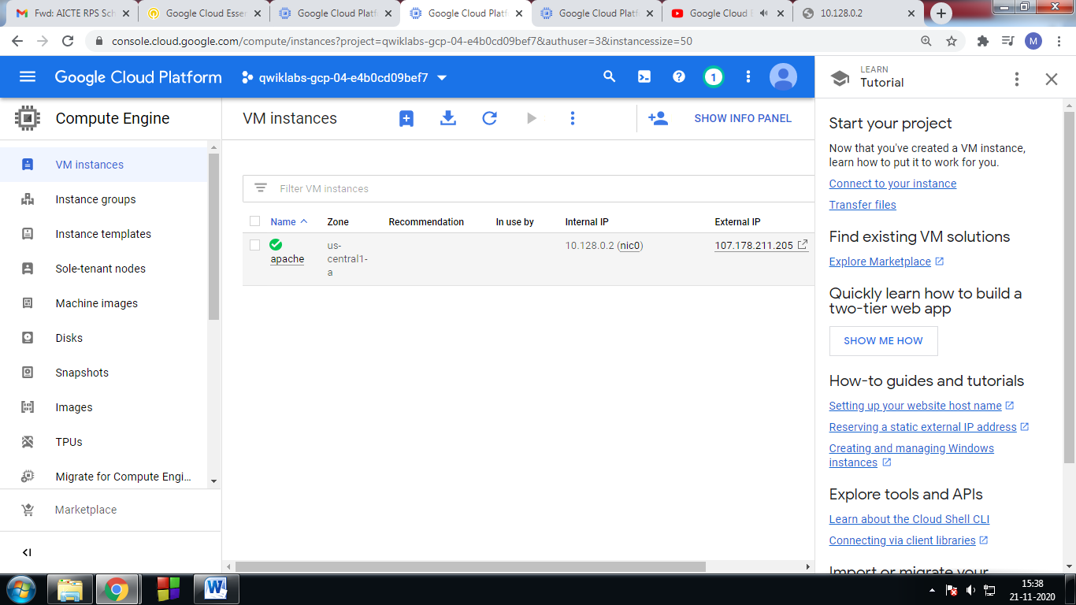

10. check your progress. 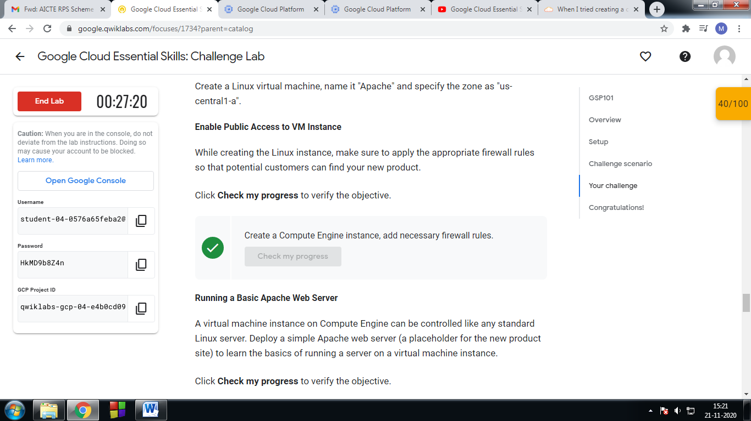

11.In the Compute Engine instance -> new created(apache) -> click on **connect SSH**

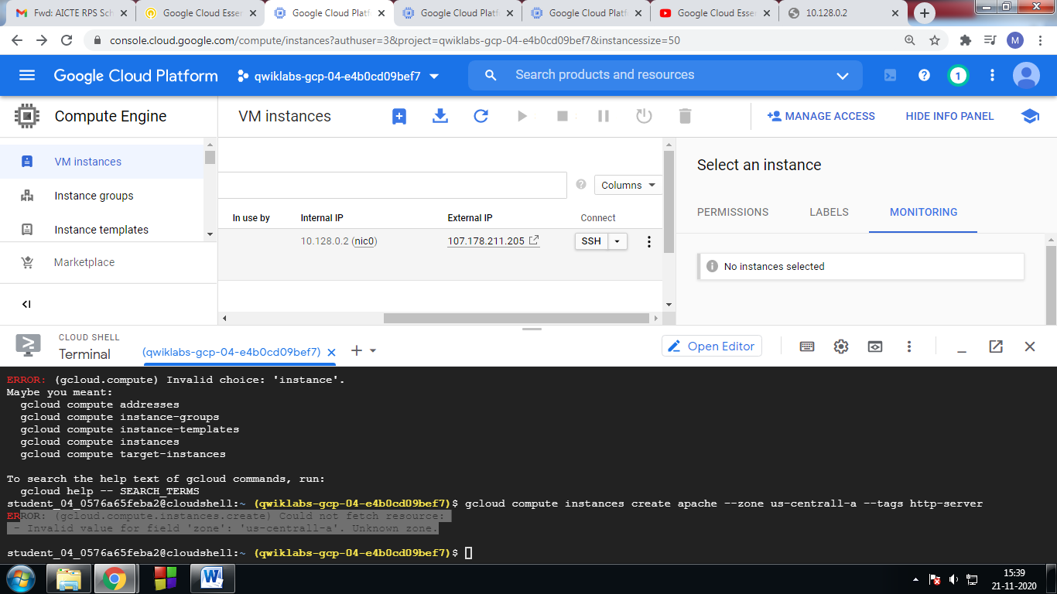

12.

Enter the following in shell

sudo su

apt-get update

apt-get install apache2 –y

service --status-all

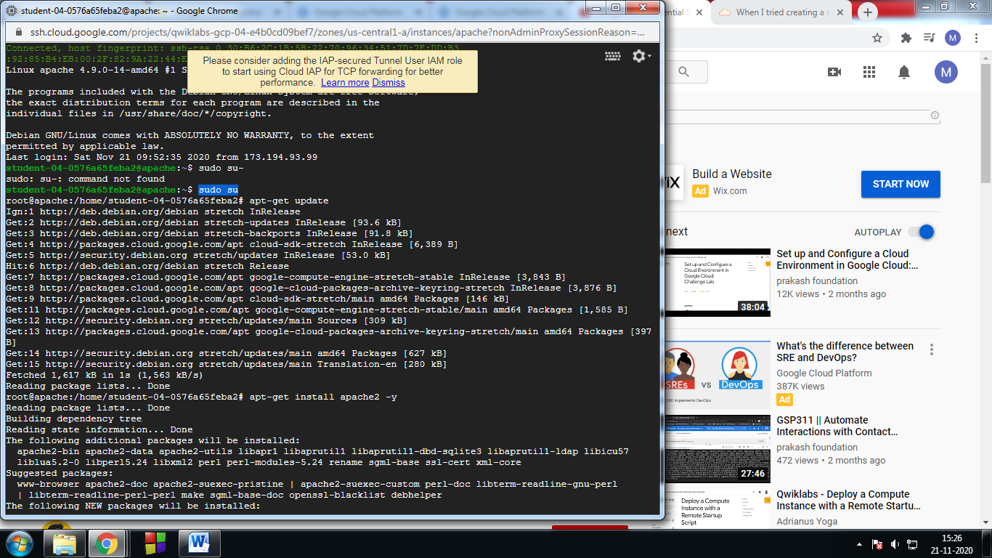

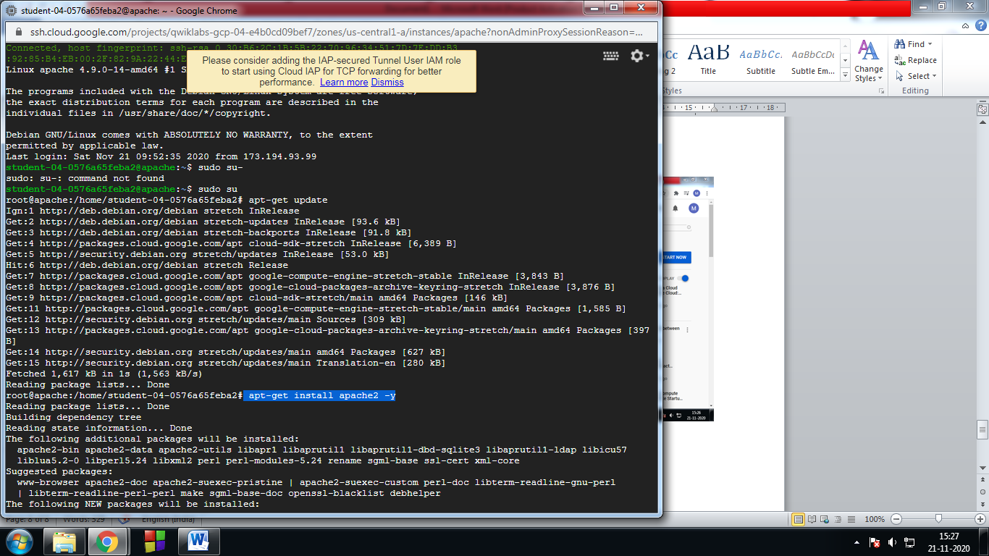

13. Check the progress of **Apache2 HTTP Server to your instance** 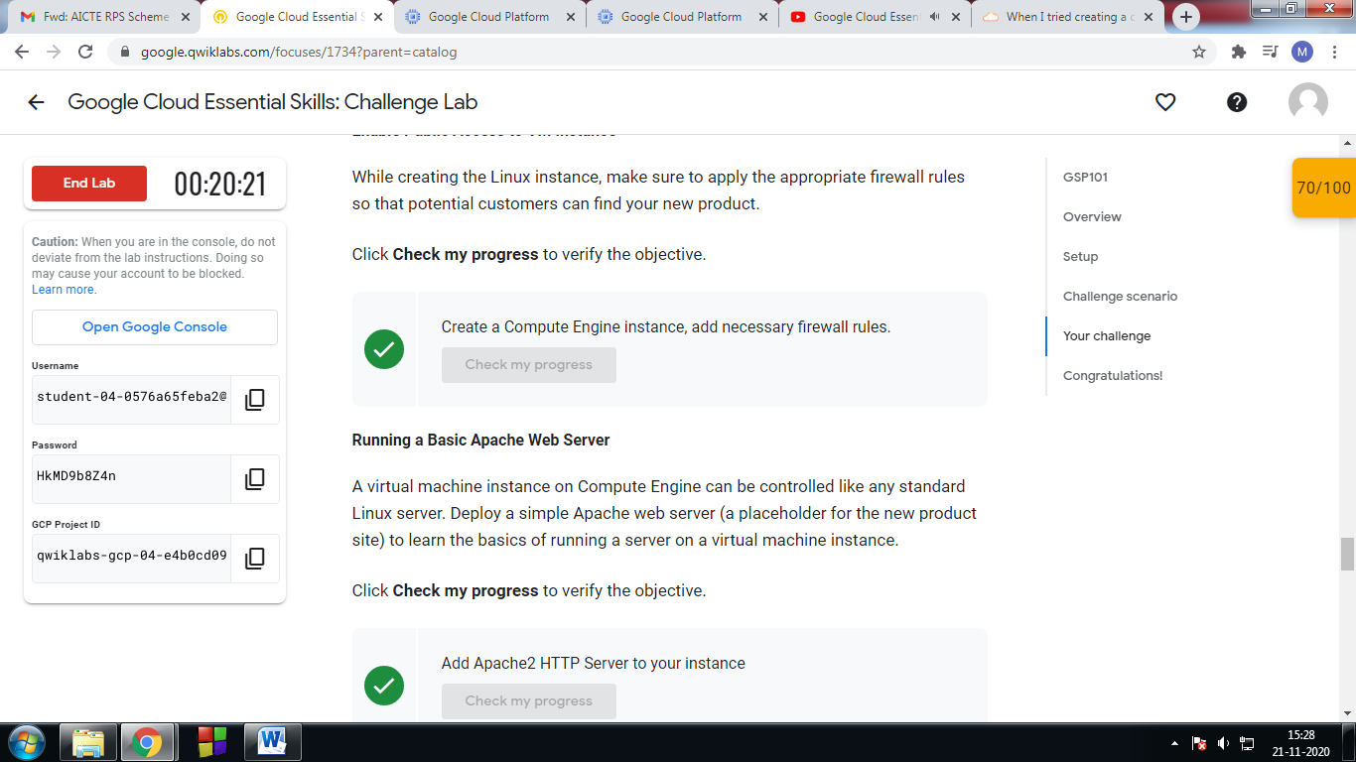

14. click on external IP address

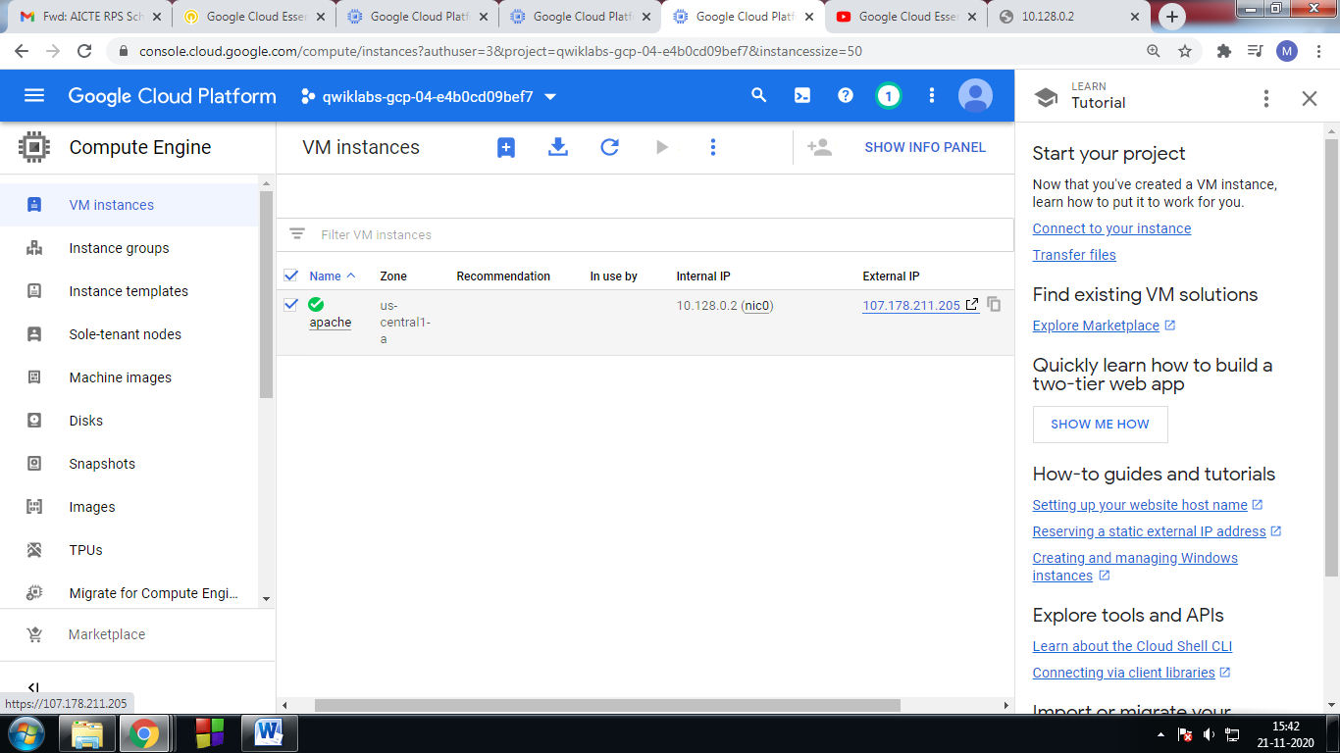

15. Finally check my Process -> Test your server 